**Project Design Phase**

**Problem – Solution Fit Template**

|  |  |
| --- | --- |
| Date | 15 February 2025 |
| Team ID | LTVIP2025TMID48259 |
| Project Name | Plugging into the Future: An Exploration of Electricity Consumption Patterns using Tableau |
| Maximum Marks | 2 Marks |

**Problem – Solution Fit Template:**

The Problem-Solution Fit means we’ve identified a clear, recurring challenge faced by stakeholders such as utility companies, policymakers, and energy analysts regarding electricity consumption. Our solution provides meaningful, data-driven insights through Tableau dashboards to address these challenges effectively.

**Purpose:**

* Analyze electricity usage patterns by time-of-day, sector, and season across different regions in India.
* Help utility companies manage load by identifying peak and off-peak periods.
* Support policymakers in designing data-driven energy policies.
* Improve communication and decision-making by visualizing insights via interactive Tableau dashboards.

**Template:**

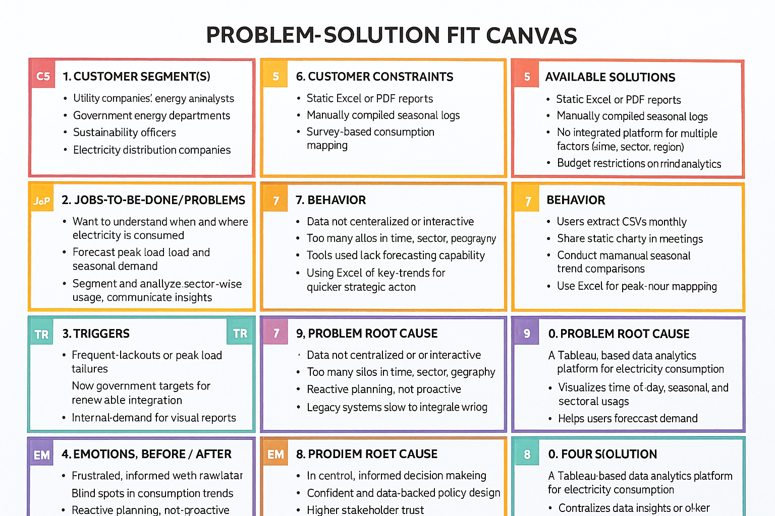

**References:**

1. <https://www.ideahackers.network/problem-solution-fit-canvas/>
2. <https://medium.com/@epicantus/problem-solution-fit-canvas-aa3dd59cb4fe>